8. Study of different types of Network cables and Practically implement the cross-wired cable and straight through cable using clamping tool
To connect two or more computers or networking devices in a network, network cables are used. There are three types of network cables; coaxial, twisted-pair, and fiber-optic.
Coaxial cable
This cable contains a conductor, insulator, braiding, and sheath. The sheath covers the braiding, the braiding covers the insulation, and the insulation covers the conductor.
The following image shows these components.
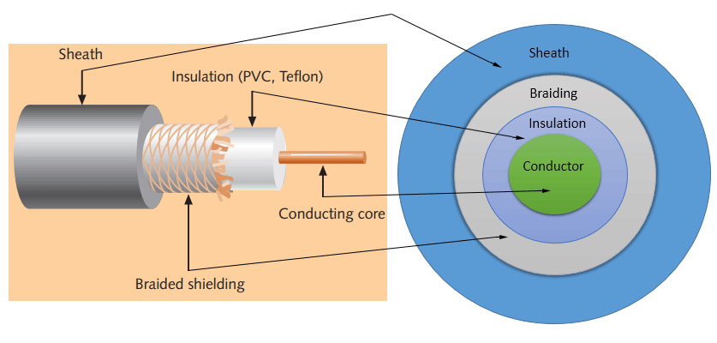
Sheath
This is the outer layer of the coaxial cable. It protects the cable from physical damage.
Braided shield
This shield protects signals from external interference and noise. This shield is built from the same metal that is used to build the core.
Insulation
Insulation protects the core. It also keeps the core separate from the braided shield. Since both the core and the braided shield use the same metal, without this layer, they will touch each other and create a short-circuit in the wire.
Conductor
The conductor carries electromagnetic signals. Based on conductor a coaxial cable can be categorized into two types; single-core coaxial cable and multi-core coaxial cable.
A single-core coaxial cable uses a single central metal (usually copper) conductor, while a multi-core coaxial cable uses multiple thin strands of metal wires. The following image shows both types of cable.
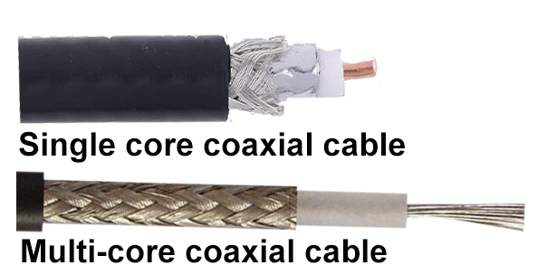
Twisted-pair cables
The twisted-pair cable was primarily developed for computer networks. This cable is also known as Ethernet cable. Almost all modern LAN computer networks use this cable.
This cable consists of color-coded pairs of insulated copper wires. Every two wires are twisted around each other to form pair. Usually, there are four pairs. Each pair has one solid color and one stripped color wire. Solid colors are blue, brown, green, and orange. In stripped color, the solid color is mixed with the white color.
Based on how pairs are stripped in the plastic sheath, there are two types of twisted-pair cable; UTP and STP.
In the UTP (Unshielded twisted-pair) cable, all pairs are wrapped in a single plastic sheath.
In the STP (Shielded twisted-pair) cable, each pair is wrapped with an additional metal shield, then all pairs are wrapped in a single outer plastic sheath.
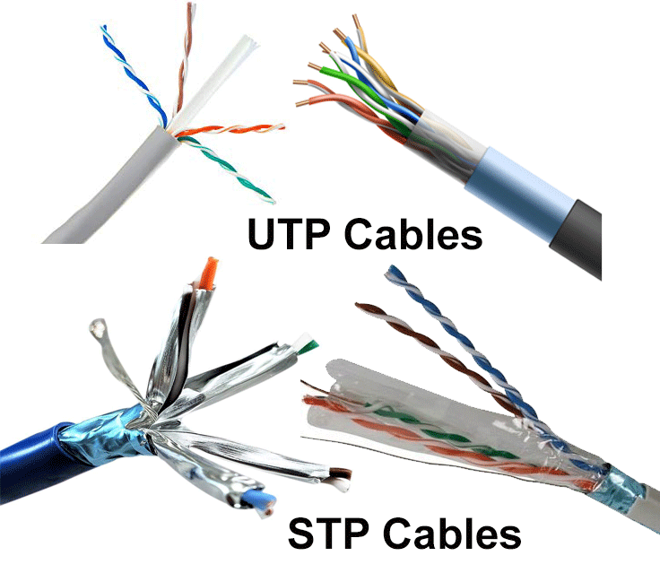
Fiber optic cable
This cable consists of a core, cladding, buffer, and jacket. The core is made from thin strands of glass or plastic that can carry data over a long distance. The core is wrapped in the cladding; the cladding is wrapped in the buffer, and the buffer is wrapped in the jacket.
- Core carries the data signals in the form of light.
- Cladding reflects light back to the core.
- Buffer protects the light from leaking.
- The jacket protects the cable from physical damage.
Fiber optic cable is completely immune to EMI and RFI. This cable can transmit data over a long distance at the highest speed. It can transmit data up to 40 kilometers at the speed of 100Gbps.
Fiber optic uses light to send data. It reflects light from one endpoint to another. Based on how many beams of light are transmitted at a given time, there are two types of fiber optical cable; SMF and MMF.
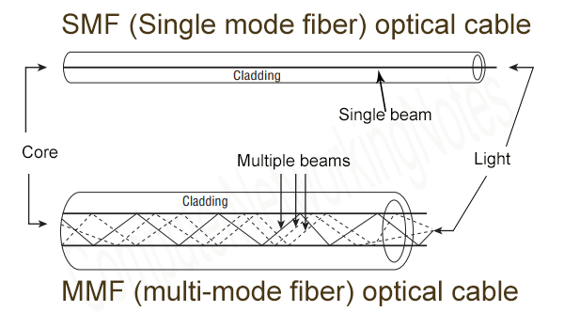
SMF (Single-mode fiber) optical cable
This cable carries only a single beam of light. This is more reliable and supports much higher bandwidth and longer distances than the MMF cable. This cable uses a laser as the light source and transmits 1300 or 1550 nano-meter wavelengths of light.
MMF (multi-mode fiber) optical cable
This cable carries multiple beams of light. Because of multiple beams, this cable carries much more data than the SMF cable. This cable is used for shorter distances. This cable uses an LED as the light source and transmits 850 or 1300 nano-meter wavelengths of light.

Practical implementation of cross-wired cable and straight through cable using clamping tool.
Procedure:
To do these practical following steps should be done:
1. Start by stripping off about 2 inches of the plastic jacket off the end of the cable. Be very careful at
this point, as to not nick or cut into the wires, which are inside. Doing so could alter the characteristics
of your cable, or even worse render is useless. Check the wires, one more time for nicks or cuts. If
there are any, just whack the whole end off, and start over.
2. Spread the wires apart, but be sure to hold onto the base of the jacket with your other hand. You do
not want the wires to become untwisted down inside the jacket. Category 5 cable must only have 1/2
of an inch of 'untwisted' wire at the end; otherwise it will be 'out of spec'. At this point, you obviously
have ALOT more than 1/2 of an inch of un-twisted wire.
3. You have 2 end jacks, which must be installed on your cable. If you are using a pre-made cable,
with one of the ends whacked off, you only have one end to install - the crossed over end. Below are
two diagrams, which show how you need to arrange the cables for each type of cable end. Decide at
this point which end you are making and examine the associated picture below.
Diagram shows you how to prepare straight through wired connection
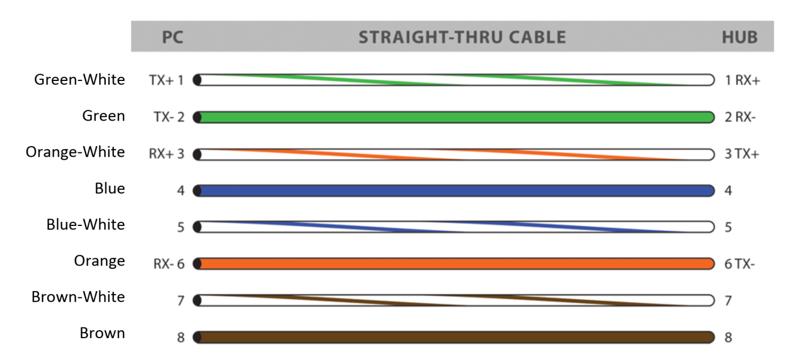

Diagram shows you how to prepare Cross wired connection
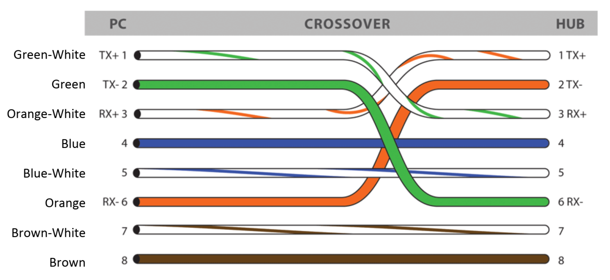

Ethernet Cable Tips:
• A straight-thru cable has identical ends.
• A crossover cable has different ends.
• A straight-thru is used as a patch cord in Ethernet connections.
• A crossover is used to connect two Ethernet devices without a hub or for connecting two hubs.
• A crossover has one end with the Orange set of wires switched with the Green set.
• Odd numbered pins are always striped; even numbered pins are always solid coloured.
• Looking at the RJ-45 with the clip facing away from you, Brown is always on the right, and pin 1 is
on the left.
• No more than 1/2" of the Ethernet cable should be untwisted otherwise it will be susceptible to
crosstalk.
• Do not deform, do not bend, do not stretch, do not staple, do not run parallel with power cables,
and do not run Ethernet cables near noise inducing components.

